BCI – PS2 RESEARCH PAPERS REVIEW
Ananya Kaushik 07111502825
- A low-latency neural inference framework for real-time handwriting recognition from EEG signals on an edge device. (Published: 20 November 2025)
Authors - Ovishake Sen Raghav, Soni Darpan, Akshar Parekh, Patrick Lehman, Sarthak Jena, Adithi Katikhaneni , Adam Khalifa & Baibhab Chatterjee.

Source Journal- Scientific Reports

MAIN AIM-
To develop a low-latency, high-accuracy system for decoding imagined handwriting from non-invasive EEG signals on a portable edge device.

CORE CONCEPTS & TECHNOLOGIES-
The Pearson correlation coefficient- It is a statistical measure that calculates the strength and direction of the linear relationship between two continuous variables.
They developed a hybrid architecture, EEdGeNet, which integrates a Temporal Convolutional Network (TCN) with a multilayer perceptron (MLP). The MLP learns which combinations indicate a particular brain state or command while TCN learns patterns such as: sudden spikes, repeating rhythms, changes over time and signal trends.
GIST OF THE PAPER-
15 healthy participants wore a 32-channel EEG headcap(a consumer-grade device). They imagined writing each of the 26 lowercase letters, plus a "do nothing" resting phase, synchronized to a metronome beat. EEG was recorded as a continuous stream and chopped into 1.5-second windows per character. Next was preprocessing, as raw EEG is contaminated by eye blinks, muscle movement, electrode drift, and electrical noise. They applied bandpass filtering (keeping only 1–50 Hz neural frequencies) followed by Artifact Subspace Reconstruction (ASR), which identifies and corrects statistical outliers within each channel. Automatic Space Reconstruction (ASR), it refers to the task of automatically restoring spaces in text where spaces are missing or incorrect. This is a common preprocessing step in natural language processing (NLP).
Crucially, preprocessing was applied per character window separately — the way a real-time system would have to work, as you can't wait to batch process. For Feature extraction, they computed 85 hand-crafted features per window covering three domains: time-domain statistics (mean, variance, Hjorth complexity, entropy measures), frequency-domain power (delta, theta, alpha, beta, gamma band power, spectral entropy), and a novel set of 65 graphical features were derived. They designed a custom hybrid architecture they call EEdGeNet. The first stage is a Temporal Convolutional Network (TCN) using dilated causal convolutions, which captures temporal and channel-wise dependencies across the 32 EEG channels. the entire pipeline runs end-to-end on portable hardware without sending data to a server.
RESULTS-
- They demonstrated real-time inference of imagined handwriting from non-invasive EEG signals, achieving a character classification accuracy of 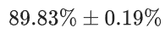 using 85 extracted features from raw EEG data.
- Implemented a real-time EEG decoding pipeline fully deployed on a portable hardware platform (NVIDIA Jetson TX2), with an average inference latency of 914.18 ms per character thereby enabling real-time BCI with minimal computational overhead.
- Developed EEdGeNet, a hybrid TCN–MLP architecture that can be efficiently deployed on the NVIDIA Jetson TX2 and achieves superior performance in imagined handwriting recognition compared to state-of-the-art EEG classifiers.\
GAPS-
- Small sample size — Only 15 participants were tested. Generalizability to diverse populations (different ages, neurological conditions) is unproven.
- Healthy participants only — The study used neurotypical individuals, not the motor-impaired patients the system is ultimately designed to help. EEG patterns could differ significantly in patients.
- Character-level, not word/sentence level — The system classifies individual imagined characters; continuous text generation or word-level decoding is not demonstrated.
- Latency still significant — Even with the optimized 10-feature set, 202 ms per character is slow compared to natural typing or speech.
- Subject-dependent training — The model is trained on each participant's own data. Cross-subject generalization (training on one person, testing on another) is not evaluated.

Future Scope-
- Future work needs hundreds of subjects spanning different ages, neurological conditions, handedness, and cultural backgrounds (writing habits differ significantly).
- Testing on the actual target population is arguably the most critical gap. The system was validated on healthy adults, but ALS patients, stroke survivors, and people with cerebral palsy have fundamentally different EEG patterns due to neuroplasticity, disuse atrophy, and altered motor cortex organization.
Our work could explore: Language model integration by pairing the neural decoder with an LLM to do predictive text completion, correcting ambiguous or misclassified characters based on linguistic context. This would dramatically boost effective communication speed even if per-character accuracy stays at ~89%.

2.Title: Revolutionizing Brain-Computer Interfaces: The Transformative Impact of Advanced AI with Reasoning Capabilities Across Functional Areas
(Published in 2025 on ResearchGate)

LINK-
(PDF) Revolutionizing Brain-Computer Interfaces The Transformative Impact of Advanced AI Across Functional Areas

MAIN AIM-
Using cutting-edge AI technologies—such as Large Language Models (LLMs) with reasoning capabilities like GPT-o1 and GPT-o3, Reinforcement Learning (RL), Graph Neural Networks (GNNs), multimodal AI, multi-agent systems, and neuro-symbolic AI—to address long-standing challenges and unlocking new opportunities in Non- Invasive BCI. A Graph Neural Network (GNN) is a neural network designed for graph-structured data. Unlike MLPs or Transformers, which typically process vectors or sequences, GNNs operate on nodes and the connections (edges) between them.

TECHNOLOGIES USED- Large Language Models (LLMs) with reasoning capabilities like GPT-o1 and GPT-o3, Reinforcement Learning (RL), Graph Neural Networks (GNNs), multimodal AI, multi-agent systems, and neuro-symbolic AI.

GIST OF THE PAPER-
- The paper examines how recent AI advancements have revolutionized Brain-Computer Interfaces (BCIs) across all functional areas — including neural signal acquisition, signal processing, communication and control, sensory feedback, and hardware integration. Flexible microelectrode arrays and non-invasive imaging systems for high-resolution neural signal acquisition, AI-powered frameworks for real-time and context-aware signal decoding, predictive communication systems for speech restoration, and multimodal feedback systems that enhance user experience were used. For Neural signal acquisition, digital Holographic Imaging (DHI) systems and enhanced EEG, with AI-powered noise reduction techniques are implemented. GNNs are employed for mapping neural connectivity, improving spatial resolution and signal clarity. Deep learning algorithms such as models like CNNs and RNNs and transformers decoded neural signals with high precision (signal processing). RNN stands for Recurrent Neural Network, a type of neural network designed to process sequential data, where the order of the inputs matters. LLMs for predictive communication and control using GPT models with reasoning capabilities empower non-verbal patients to communicate were implemented along with robotic control RL-based adaptive systems for precise prosthetic and robotic control. AI-enhanced feedback loops including Adaptive learning systems to optimize feedback for personalized experiences and neuro-symbolic AI to Improve interpretability and reliability in sensory feedback mechanisms were used for obtaining sensory feedback.
RESEARCH GAPS-
1. Signal reliability in real-world settings — Their AI-BCI system was validated in a controlled lab environment. Noise, artefacts, and inter-subject variability remain unresolved for real-world deployment.
2. Cross-subject generalization — Most models are trained on individual-specific data. Building AI models that generalize across users without extensive re-calibration is still an open problem.
3. Explain ability of AI decisions — Deep learning models (GNNs, LLMs) used for neural decoding are largely black boxes; interpretability in safety-critical clinical settings is a critical gap.
FUTURE SCOPE/ WHAT OUR WORK CAN EXPLORE-
1.Addition of brain-to-cloud interfaces as a key future direction — where neural signals are streamed in real-time to cloud-based AI systems for processing, storage, and analysis at scales impossible on local hardware. This would allow continuous monitoring, remote clinical oversight, and population-level neural data insights.
2. Embedding LLMs directly into the decoding pipeline — where the language model acts not just as a post-processor but as a probabilistic prior that shapes neural decoding in real time, enabling open-vocabulary speech synthesis at near-conversational speeds.
3. The precise technical future is online RL agents that continuously re-optimize the mapping between neural states and device commands based on user feedback — so the decoder adapts in real time as neural representations drift without requiring manual recalibration sessions.

3 EEG2TEXT: OpenVocabulary EEG-to-Text Decoding with EEG Pre-Training and Multi-View Transformer. (Published in 2024)
LINK- 2405.02165
MAIN AIM-
Improve open-vocabulary (tens of thousands of words) EEG-to-text decoding accuracy, while removing the dependence on eye-tracking-based word-level feature extraction so the approach can generalize to harder settings like inner speech. Previous studies of EEG-to text decoding have achieved high accuracy on small closed vocabularies, but still fall short of high accuracy when dealing with large open vocabularies.
GIST OF THE PAPER-
They have proposed a novel method, EEG2TEXT, to improve the accuracy of open vocabulary EEG-to text decoding. Specifically, EEG2TEXT leverages EEG pre-training to enhance the learning of semantics from EEG signals and proposes a multi view transformer to model the EEG signal processing by different spatial regions of the brain. First, they introduced a Convolutional Neural Network (CNN) module before the base transformer model to enhance the model’s ability to handle long EEG signals. A CNN (Convolutional Neural Network) is a type of neural network that automatically learns useful patterns from data. Second, they conducted pre-training of the transformer model by reconstructing randomly masked EEG signals from the input data. Lastly, they proposed a multi-view transformer architecture, where each single-view transformer is the pre-trained model from the previous step, to model the EEG signal processing by different spatial regions of the brain. A Multi-View Transformer is a transformer that looks at the same data from multiple perspectives ("views") and then combines those perspectives to make a better prediction. A Multi-View Transformer views the EEG signal through Time-domain view, Frequency-domain view and spatial view. In the baseline model, the word-level EEG features are extracted from eight independent frequency bands from the raw EEG signals. They have Trained/evaluated on ZuCo (12 subjects reading English) plus Image-EEG for pre-training.

RESEARCH FINDINGS-
1.Using sentence-level EEG signals offers several advantages over word-level EEG features. It provides richer information without error propagation from the eye-tracking data and exhibits better generalizability to other tasks, such as inner speech decoding, where acquiring eye-tracking data is infeasible.
2. The sentence-level EEG signals pose a challenge due to their excessive length, potentially overloading laboratory-level GPUs if directly input into the transformer layer. To tackle this issue, they have introduced a convolutional transformer model that incorporates a CNN module for compressing raw EEG signals.
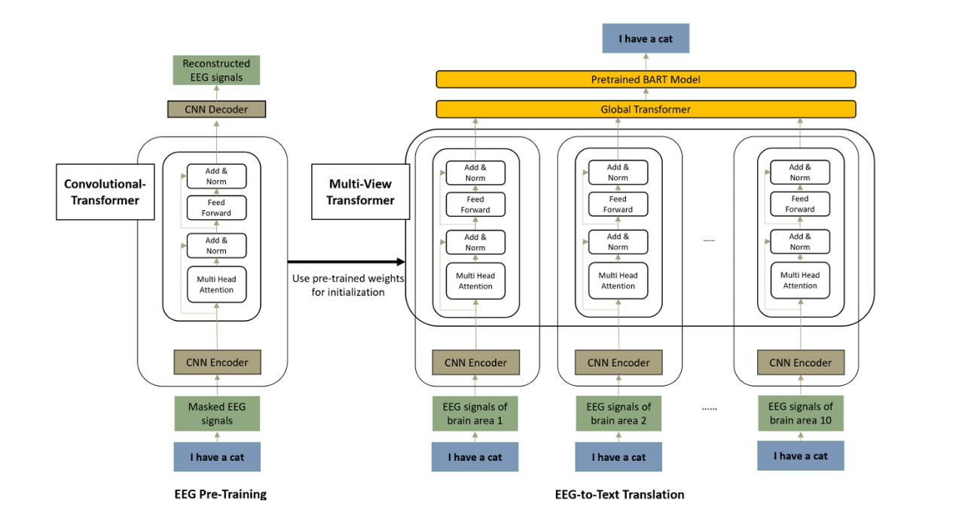
3.Multi-View Transformer- Partitions 105 electrodes into 10 groups mapped to functional brain regions (Broca's, Wernicke's, auditory, visual, etc.), each encoded by its own convolutional transformer, then fused by a global transformer feeding BART. This adds spatial-resolution modelling that prior work ignored.

RESEARCH GAPS+WHAT OUR WORK COULD EXPLORE-
- Single primary dataset and small subject count (12) due to which Generalization across subjects, languages, and recording setups is untested.
- Reading-only paradigm- Despite motivating inner-speech decoding, all experiments are on EEG recorded while reading displayed text — actual inner/imagined speech decoding isn't demonstrated
- GPU-bound architecture is a key drawback of the paper. They note the multi-view model could improve further with more activated convolutional transformers per epoch, but compute limits capped this at three.

We can extend the model to EEG from diverse multi-modal sources, building on the demonstrated compatibility with image-EEG data for higher accuracy and increased user compatibility.

Synthesizing intelligible utterances from EEG of imagined speech.

Authors: Wenjing Xiong, Lin Ma and Haifeng Li.
(Published Frontier Neuroscience, 17 April 2025)

MAIN AIM-
The paper's core goal is to synthesize audible, intelligible Chinese speech directly from EEG recorded during imagined (covert) speech, using a non-invasive approach. The motivation is restoring communication for people who can't speak due to paralysis or aphasia, and doing it without surgery — unlike the ECoG/sEEG/intracortical systems that dominate this field. They presented an EEG-to-speech system (ETS) that synthesizes audible, and highly understandable language by EEG of imagined speech.

GIST OF THE PAPER-
They designed an EEG-to-speech system (ETS) built around two "X-shaped" deep neural networks. ETS applies a specially designed X-shape deep neural network (DNN) to realize an End-to-End correspondence between imagined speech EEG and the speech. The system innovatively incorporates dynamic time warping into the network’s training process, using actual speech EEG data as a bridge to temporally align imagined speech EEG signals with speech signals. The ETS performance was evaluated on 13 participants who pretraining four Chinese disyllabic words. These words cover all four tones and 40% of the phonemes in Chinese. The synthesized utterances’ average accuracy across all subjects was 91.23%, and the best accuracy was 99%. Furthermore, a partial feedback mechanism for DNN and spectral subtraction-based speech enhancement were introduced to improve the quality of generated speech. They chose 4 words for which the stimulus presentation duration was allotted two seconds. That is, there are 15 trials for each word, for a total of 60 trials for each subject. In a single trial, we designed three tasks, which were: the resting task, the reading task, and the imaging reading task.
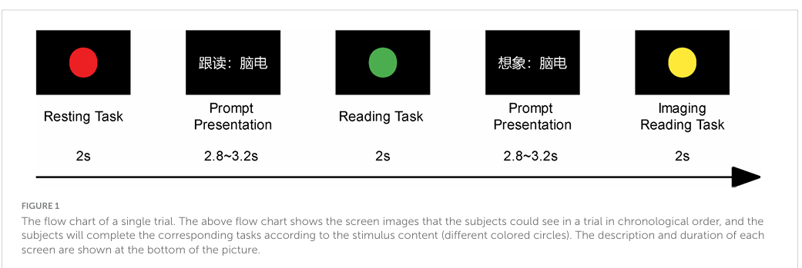

Subjects were instructed to look at the “+” symbol in the middle of the screen, maintain focus, and respond rapidly after the stimulus was presented in each block. Regarding potential EEG influences, primary visual cortex (V1) neurons are known to respond selectively to different wavelengths of visible light, allowing participants to process the signal lights rapidly without deeper visual processing.
RESULTS-
- As Imagined speech produces no sound, so there's no natural time-aligned target to train against. Their trick: collect overt (spoken) speech EEG too, since overt speech EEG and the recorded speech are naturally aligned in time.
- Tested on 13 subjects with four disyllabic Chinese words. Average intelligibility across subjects was 91.23%, average MOS was 3.50, with a best case of 99% accuracy and MOS 3.99. They claim this is the first time imagined-speech neural activity has been used to synthesize high-quality intelligible speech non-invasively. MOS or Mean Opinion Score is a measure of how good the generated speech sounds to human listeners.
RESEARCH GAPS-
- Tiny, closed vocabulary is the main limitation of the paper. The study is limited to four disyllabic Chinese words — nowhere near open-vocabulary text generation.
- No cross-subject generalization- The system's generalization to unseen subjects remains a challenge due to EEG signal variability across individuals. Every model is trained within-subject.
- This approach requires overt-speech EEG as a training crutch meaning the whole alignment scheme depends on first recording the user actually speaking — which defeats the purpose for a fully paralyzed/aphasic user who can't vocalize.
- No language/semantic modelling- They deliberately avoid the LLM-based semantic decoding route (Tang et al. 2023, fMRI), which they note solved fMRI temporal lag via an LLM but suffered a gap between semantic and lexical accuracy and couldn't decode across subjects.

WHAT WE COULD IMPROVE-
- Implementing Adaptive learning techniques and larger participant groups to improve robustness and inter-subject consistency.
- Scaling to other languages, which they argue their waveform-level design supports natively.
- A language-model decoding head (the actual thought-to-text piece). This paper does EEG→ waveform, no linguistics. The missing component is exactly what their fMRI work added: pair the neural decoder with an LLM that supplies linguistic priors and corrects acoustically ambiguous outputs. This is the single biggest addition needed to convert this from speech-synthesis into low-latency text.
- Implementing subject-adversarial training to learn subject-invariant features, a domain-adaptation fine-tuning stage, or meta-learning (MAML-style) so a new user calibrates in minutes rather than a full data-collection session. A 13-subject within-subject result doesn't tell us whether the method generalizes at all.

